What Do Pumpkin Spice Lattes & Crunchwrap Supremes Have To Do With Gender?
Alexander D Minton
Loyola University Chicago

Author Note
Thank you to Dr. Sredl for challenging me to think outside the bun and allowing me to embrace vulnerability.

What Do Pumpkin Spice Lattes & Crunchwrap Supremes Have To Do With Gender?

Research Question
How are corporate brands gendered in the marketplace? Do those genders reflect the brand’s perfect customer through advertising?

Why It’s Important
Everything has a gender. Whether it is Barbie staring you in the face from an aisle at Wal-Mart, to a local financial service team where 23% of the staff are women. Wouldn’t it be interesting to see if the living, breathing Starbucks or Taco Bell could sit down and have dinner with you? What would they look like? How old would they be? What are their interests? My research goes beyond the gender of the CEO, and dives into the messaging, advertisements, and aesthetic of corporate brands. I seek to unpack their corporate gender binary through a blended method of content analysis and literature review. Specifically, I am curious about two quick-service brands in particular: Starbucks and Taco Bell. Through a content analysis involving advertisements around Pumpkin Spice Lattes and Crunchwrap Supremes, I am looking to uncover who is really hiding behind the corporate branding curtain for each of these companies. Due to the meticulous details that makeup the gender of a corporation, I will have to devote a heavy amount of time describing the background information of the corporate gender binary, its strategy, and the design elements that suggest gender. With all of this critical framework established, the analysis of Starbucks and Taco Bell will then follow suit.
The Corporate Gender Binary
Before I dive into the corporate gender binary, it is important to illustrate how corporate brands got their gender in the first place based off previous scholarship. Grohmann suggests in 2016 that the gender of a brand is an aspect of the brand’s personality, a brand’s personality is characterized as human personality traits that consumers associate with brands. The two dimensions of brand personality are masculine and feminine. (Grohmann 2016). She expands upon this argument by saying that every decision a brand makes in its appearance (ie. brand name, logo, type font) is a representation of the brand’s personality. On top of appearance, the way a brand chooses to communicate via a spokesperson or advertising efforts conveys the communication style of the brand to a consumer. Lastly, even a brand’s behavior through its performance and experience are an overall representation of the gender of the brand (Grohmann 2016). For now, this evidence suggests that a brand is like a human being. It has a voice, it has an appearance, and it behaves in a certain way. As consumers’ preferences change, brands need to be aware that their overall identities can either attract consumers or push them away. Grohmann sums this up by detailing the appearance, communication, and behavior to convince a brand’s personality resembles the social surroundings that the brand is advertised in (Grohmann 2016). Thus, scholars are interested in the gender of brands and how they connect to the consumer. Grohmann’s research has shown, brands are gendered and have masculine and feminine dimensions. Building on this work, Lieven et al. (2014) prove that high levels of brand femininity and masculinity elicit higher ratings of brand equity. Scholars have also examined the influence of brand design (Lieven et al., 2015) and linguistic elements (Yorkston and de Mello, 2005; Wu et al., 2013; Guevremont and Grohmann, 2015) on brand gender perception (Azar and Ulrich 2018).
With consumer’s placing a higher emphasis on trust in a brand, it is clearly demonstrated for a brand to fully understand who they are, what they look like, how they act, and who they support. Ultimately, all of these decisions impact the overall identity of a brand, “This new approach to brand gender leads to the emergence of four brand genders: masculine (high on masculinity and low on femininity), feminine (high on femininity and low on masculinity), androgynous (high on both dimensions) and undifferentiated (low on both dimensions)” (Azar and Ulrich 2018). Gender no longer directly applies to human beings, but its characteristics and classifications have now stretched themselves into the non-living world in the form of brands. Marketers now need to make conscious decisions within their campaigns to match an authentic connection with their target audience. They need to ask themselves the question: Who are we? What do we stand for? Who will we impact the most? How do they achieve this connection? Through content.
Summary
In summary, this section has defined how brands received their gender in the first place, defined the importance of consumers perception of brands, offered a strategy for the framework for the rest of this analysis, and tied in how vulnerability and empowerment can be a strong influence in advertising. What I find to be the thread in this section is the consumer. At the end of the day, the consumer is a brand’s central focus. Once a brand embodies vulnerability with itself, and matches their appearance, behavior, and communication to their consumer they can begin to truly understand them. My research question will build upon this framework of research and dig into the branding decisions behind two of the largest quick-service restaurants in the world. My analysis will add a new perspective to the table, analyzing how the logo, color, type font, and product offerings align with the consumer. Through the branded house strategy in conjunction with Azar’s four brand genders approach (2018), I will determine whether or not Starbucks and Taco Bell are heavily masculine, feminine, or if they elicit and androgynous identity. This analysis of branded corporations is an extension to the already vast discussion of gender and society. I think that there is extensive research rooted in understanding humanity and gender, but the idea that human beings emulate gender norms in all aspects of life is fascinating. Because gender used to be seen as only biological and applicable to life forms, the extension of it into the non-life form of a brand demonstrates how society has evolved with gender over time. Furthermore, seeing how gender bleeds into the marketplace, and how different brands are subconsciously gendered can open up a whole new conversation surrounding gender bias in branding. Marketers and researchers can use this information to uncover how consumers relate to the gender of brands, and how even something so extraneous as lattes and tacos embody a gender once marketed.
Methods
Literature Review
With the background information and degree of importance established, now the analysis can begin on what specific attributes of a brand correlate with a certain gender. To follow the four branded genders model by Azar (2018), the two sides to gender are masculine and feminine. Each of these genders are associated with their own shapes, colors, sounds, designs, attractiveness, and behavior. The interesting approach to corporate branding is that most corporate brands do not have a person associated with them that easily communicates gender. Grohmann’s research supports this claim, “in the absence of more diagnostic brand information or experience with the brand, consumers rely on the accessible brand elements, such as type font and logo to judge the brand (Batra, Lehmann, and Singh 1993)” (Grohmann 2016).
Font Type
To help address the elements of corporate branding, Grohmann first describes a brand’s font choice as a clear indicator for gender. Combining prior research with their own findings, their results are as follows: “In the context of Jounal of Marketing Communications 4053 web usability, Shaikh, Chaparro, and Fox (2006) examine 20 type fonts and empirically establish type font groups that are associated with specific personalities: Serif fonts (i.e., fonts characterized by small horizontal or vertical appendices [serifs] to letters; e.g., Times New Roman or Georgia) appear traditional, sans serif fonts (i.e., fonts without serifs: Arial, Verdana, or Century Gothic) are considered all purpose, and script fonts (i.e., fonts that appear hand written and organic: Comic Sans or Monotype Corsiva) convey happiness and creativity. Monospaced fonts (i.e., fonts with fixed letter width: Courier New) are considered plain. Finally, display fonts (i.e., static looking fonts that are suitable for large letter sizes associated with displays: Impact, Agency FB) are assertive and bold” (Grohmann 2016). The analysis of font types continues with, “Tantillo, Di Lorenzo-Aiss, and Mathisen (1995) examine differences in the perception of serif and sans serif type fonts, and find that consumers consider serif type fonts (Century Schoolbook, Goudy Old Style, New Times Roman) more elegant, charming, emotional, distinct, beautiful, and interesting, whereas sans serif type fonts (Avant Garde Gothic, Helvetica, and Univers) appear manly, powerful, smart, upper-class, readable, and loud” (Grohmann 2016).
This blended research suggests that something so microscopic as a sharp edge on a letter has macrolevel gender perceptions. Thus, fonts that are assertive, bold, and take up more space on an advertisement are considered to be masculine. The two different categories within the Sans Serif group can be correlated with gender. The manly, powerful, and loud avant garde, gothic, and Helvetica would fall towards the masculine end of the gender spectrum. Whereas, fonts that are scripted, curly, containing rounded edges, and are thinner (ie. Century Schoolbook, Goudy) in design are associated with a feminine brand. This research has a large contribution to the conversation around the importance of branded gender because of the adjectives used to describe a font. Typeface fonts that are whimsical, charming, and emotional imply that brands who use these fonts are made for women. Therefore, by purchasing a product that is advertised with by an emotional font suggests that you are an emotionally vulnerable person. In class discussions, we have spoken extensively around the issue of emotion and vulnerability in gender. Society has deemed men unfit to convey emotion, restricting them to hide it. For instance, “Zayer and Otnes (2012) find that while some men report feeling that images of masculinity are aspirational, some experience anxiety about living up to societal standards. Thus, while it is clear that men, at least in some cases, do make comparisons to advertising depictions, scholars to date have not attended specifically to how or if advertising professionals perceive ethical dilemmas that involve male consumers at all” (Zayer and Coleman 2014). Therefore, if something so simple as a font choice is associated with a gender how can marketers promote their product to all consumers without imposing societal stereotypes? This research reinforces that gender is embedded in everything we do and everything we see.
Brand Design & Logo Appearance
With one piece of the puzzle addressed, it’s time to shift gears towards the appearance of a brand. A logo is one of the most important aspects of a brand’s gender. It is the physical stimuli which produces a snap judgment within consumers. Prior research suggests that the shape of a logo is the groundwork for a gendered perception. For example, “Two dimensions of physical appearance – angularity versus roundness, and heavier versus slender build – appear to play an important role in these perceptions: the literature suggests that an angular, V-shaped torso consistent with physical strength and muscle development in the upper body increases perceived attractiveness in men (Furnham and Radley, 1989)” (Lieven, Grohmann, Herrmann, Landwehr, Van Tillburg 2015). This research supports the same ideas behind rounded fonts and sharp-edged fonts. If a font has sharp corners it is masculine, just as if a logo has more structured and rigid features it is implied to be more muscular which suggests a more masculine brand. Whereas it was established above that more curvy and thinner fonts are associated with a feminine brand. Based off previous discussion in this analysis, a brand in today’s society is like a human being. Therefore, a brand’s appearance can be judged and deemed attractive or not. For instance, “a highly masculine appearance indicating strength and status, or a highly feminine appearance indicating fertility is often considered attractive (Etcoff, 2000). The relation between masculinity or femininity and attractiveness may suggest that there is a link between highly masculine and feminine brands and consumers’ responses to such brands” (Lieven, Grohmann, Herrmann, Landwehr, Van Tillburg 2015). If the brand’s gender coincides with its target audience, then I presume the consumer has a newly assumed image of themselves within society just for consuming the brand. Consumers who respond to highly attractive brands continue to purchase products from these brands, so they can continue to feel attractive. Brands capitalize on consumers’ desires to fit in or stand out. For example, if a male identified individual purchases a product from a brand with a community of males surrounding its brand image, clouding its collateral, and suggested by its font and logo guidelines – this man will feel more like a man. Marketing managers are indeed aware of matching these physical brand traits to their target consumer. It builds brand equity with the consumer and signals that the brand is relatable to the consumer’s identity. Brands like Taco Bell and Starbucks in business to sell product, therefore aligning their brand with the perfect customer is key to drive the business.
Moving into the realm of specific color choices, “The relation between color and masculinity/femininity perceptions is often examined in the context of sex-related stereotyping of colors in socialization processes (Picariello et al., 1990; Pomerleau et al., 1990) and the cultural perpetuation of gender-stereotypes related to color associations (Cunningham and Macrae, 2011)” (Lieven, Grohmann, Herrmann, Landwehr, Van Tillburg 2015). Lieven and their research team concluded that lighter colors are perceived more feminine, while darker colors are more masculine. (Lieven, Grohmann, Herrmann, Landwehr, Van Tillburg 2015). Ultimately, “The relation between color and masculinity/femininity perceptions is often examined in the context of sex-related stereotyping of colors in socialization processes (Picariello et al., 1990; Pomerleau et al., 1990) and the cultural perpetuation of gender-stereotypes related to color associations (Cunningham and Macrae, 2011)” (Lieven, Grohmann, Herrmann, Landwehr, Van Tillburg 2015). When combined with a complementary type font, a brand whose logo and type match genders can have a resounding impact of brand perception. This idea is supported by the use of congruent cues, matching brand name and logo or type font and sound, result in a synergy in the consumers mind that those two physical attributes of a brand have a gender in common. This is put into practice with script type fonts (associated with femininity) applied to feminine brand names to strengthen a feminine brand perception whereas display type fonts (associated with masculinity) applied to masculine brand names strengthen a masculine brand perception. (Grohmann 2016).
Sound of the Brand
Lastly, even the sound of a word has a gender association. “Specifically, stop consonants (e.g. k/p/t) increase the perception of masculinity, while fricatives (e.g. s/f) increase the perception of femininity (Klink, 2000; Guevremont and Grohmann, 2015). Front vowels (e.g. i) suggest a feminine brand personality, whereas back vowels (e.g. o) create a masculine brand personality (Wu et al., 2013)” (Azar and Ulrich 2018). Thus, I am going to condense Grohmann’s argument of the synergy of a brand’s gender into a formula: the gender of the logo + gender of the font + gender of the sound of the brand name = overall gender of the brand.
Content Analysis
With the three baselines of font, logo appearance, and sound established, a content analysis of two quick-service companies, Starbucks and Taco Bell, can be examined, analyzed, and their genders are interpretable. Grohmann’s (2016) formula will be used to identify the gender of the brand based on its logo, font, and sound within the content analysis. Whereas Azar and Ulrich’s (2018) gender scale will be used to see if the gender of the brand connects with the gender of the target consumer. Together, these two methods will either support or deny my research question.
Starbucks Coffee
To begin with Starbucks, let’s examine the company’s most updated logo in Figure 1 from the outside in. Right off the bat, notice the rounded circle. The rounded edges of the circle are in tandem with Lieven’s research. Based off the angular and circular shape of the logo, Starbucks has a more feminine brand design. Now, onto the type font. The Starbucks type font is bold, with sharp edges rounding each corner. Notice how all of the letters have sharp points at the end of each letter. When analyzing the angle of each sharp, the reader may notice a V shape (see Figure 1.1).
The Starbucks logo is closely related to the Arial Bold family, and research suggests that Arial fonts are more of an all-purpose font. I would characterize an all-purpose font as more androgynous in relation to the four-gender scale. The interesting thing about Starbucks lettering is how their edges match up with the design theory that V-shapes assert a more masculine presence. I believe the Starbucks designers chose this assertive, sharp edge to contrast the center-piece of their logo: the infamous Starbucks Siren. According to Steve Murray, a creative director in the Starbucks Global Creative Studio, “‘She is not a real person, but we kind of think of her as one. She’s the biggest symbol of our brand, really, other than our partners (employees). She’s the face of it’” (Flanderau 2016). The founders of Starbucks were called to use the siren as a logo because of their port city headquarters in Seattle, and the fact that coffee has to be delivered long distances across the ocean.
The Siren embodies more than just their physical location, but also the attitude in which Starbucks employees aim to treat each other, their customers, and the world – with goodness. (Flanderau 2016). From a gender perspective, the use of a female siren clearly communicates the feminine aspect of the Starbucks brand. Her wavy hair and feminine features draw customers in, specifically male customers. I view this choice as one to attract men into trying their coffee, with the hopes they will soon be captivated with the rich roasts and variety of menu items. It is important to tie in the sexualization of the Starbucks siren because I believe it is a key component to gender and marketing in today’s society. Jhally (1987) phrased it best: “In modern advertising, gender is probably the social resource that is used most by advertisers. Thousands of images surround us every day of our lives that address us along gender lines. Advertising seems to be obsessed with gender and sexuality” (Jhally 1987). Sex sells advertising, and Starbucks’ use of the siren is their subtle decision to sell their brand.
With the majority of the physical attributes of the logo analyzed, it is now time to analyze the color and phonetic choices associated with the Starbucks brand. In conjunction with the research presented above surrounding color, lighter based colors are said to possess more feminine qualities, while masculine colors are darker. I would argue that the shade of green the Starbucks logo uses is almost a direct mix of light and dark colors. I can see the thought process behind mixing darker hued greens and lighter hues to convey a more androgynous and neutral brand tone. If the company were to incorporate bright colors like pink, orange, or yellow than they may alienate a large portion of their coffee consumption consumer base. From a phonetic analysis, Starbucks actually contains more masculine syllables. The soft “S” to begin and end the word is soon overpowered with a hard “TAR-bu-CKS” towards the end. This sharp, hard tone sandwiched between sweet sounds inflects a more feminine beginning, masculine middle, and feminine ending. Following Grohmann’s (2016) formula the gender of the logo is feminine, the gender of the font is masculine, and the gender of the brand name is also feminine. Making Starbucks the brand: predominantly masculine.
From Brand Product: The Pumpkin Spice Latte
Having established the Starbucks brand as feminine, I wanted to see if one of their most popular seasonal drink items matches with the overall gender of the brand. The Pumpkin Spice Latte is an annual fall treat which has swept the nation. According to Inc magazine, the Pumpkin Spice Latte was actually invented by a Stanford male basketball player in 2003. The graduate, Peter Dukes, faced some backlash for designing the drink – but today is honored as an inducted member of the Starbucks Hall of Fame (Curtin 2018). The drink has manifested itself into a fall icon. Captivating meme culture, social media conversation, and has even molded itself into the “Basic White Girl” description on Urban Dictionary (Basic White Girl n.d.). The drink has absorbed its gender based off its feminine consumer’s tastes and societal perceptions. Even Starbucks advertising has begun to reflect a more feminine display over time.
To begin the content analysis of Figure 2, which displays a Pumpkin Spice Latte Advertisement in 2018, I will first analyze the physical shapes in the ad. The design elements on the advertisement do not take up as much space on the page. Its simplistic and bright display with no text implies that Starbucks consumer base is already aware of what is inside the cup -they need no textual product recall. The inclusion of the pumpkins suggests a curvier design structure, which is more appealing to a feminine eye. Additionally, the pumpkins are representative of the time of year the product is advertised and consumed. As for the color choices, the bright orange and soft pinks in the advertisement contribute to the feminine essence. The most conveying component, however, is the female’s hand who holds the latte. Her grip is rather light, and her nail polish complements the soft background color. Overall, the Pumpkin Spice Latte shows feminine qualities on all of the design tests that researchers have established. Additionally, the product’s positioning towards a female customer is complementary to its societal perception of the drink. Starbucks is obviously well aware of their product’s demographics and hone in on those qualities to drive sales and complement gender.
Conclusion: Tying in the Consumer
In conclusion, knowing the Starbucks brand would have to be defined as predominately female based off Grohmann’s (2016). At the heart of their brand is a female Siren, whose mystic voice and enticing aromas captivate sailors far and wide. Additionally, one of the companies most popular and well-known beverages, the Pumpkin Spice Latte, has become associated with basic white girl culture and is even advertised to female consumers. The Ulrich (2018) scale would align Starbucks as feminine. Even though a male created the beverage, it is ultimately evident of how consumers can influence the gender of the product. Brands simply react to how consumers perceive and popularize each product. At the end of the day, Starbucks is no fool – she understands her perfect customer and stays true to her oceanic roots.
Taco Bell
Moving from early morning essentials to late night cravings, Figure 3 depicts Taco Bell’s most recent update to the company’s image from 2016. One brand blogger said that the new logo was the least-appetizing choice the company could have chosen. They noted that the logo is designed simply for a reason, so that the iconic “bell” could take on any skin it wants (Armin 2016). That comment begs the question: can Taco Bell take on any gender it wants with this new logo?
The physical appearance of the Taco Bell logo in Figure 3 depicts a curvy shaped bright purple outline of the iconic bell. Taco Bell’s latest brand design incorporates neon colors to communicate a more vibrant tone for the brand. Their brand redesign came at the opening of their newest store location, The Taco Bell Cantina, in Las Vegas. This full-suite Taco Bell also has a liquor license and since its opening, more Cantina’s have popped up around the country. The curviness of the bell aligns with Etcoff’s (2000) research that curvy logos and thinner fonts are more feminine While the makeup of the bell may be feminine, the logo itself is more fluid. Coupled with the idea that the use of a white bell is so that the brand can take on any skin or format, I see how the brand is positioning itself to be more gender neutral. The bell does not directly identify with a certain gender. Set behind a purple background, in accordance to Grohmann et.al (2015) sex-stereotyping argument with brand’s color choices, the brand is identified more with a gender neutral identity. Purple is more gender neutral as it is a mixture of the male stereotyped color blue and the female stereotyped color pink.
Digging deeper into the makeup of the bell, the reasoning behind a curvy and thin logo design is because it communicates attractiveness and fertility (Etcoff 2000). Once again, the notion of sex enters the discussion of gendered brands. Similar to the discussion with Starbucks, I find it fascinating that a simple curve of a bell can have a microscopic interpretation of fertility. While this may not be top-of-mind to Taco Bell managers, I still find the thread to be important. It represents the systematic foundation of sexualization within gender and marketing. While the focus of my research is about the gender of brands, it is still important to address the branch of sexuality that exists within gender. By default, a brand with a gender also has some merit to having a sex appeal.
Moving on to the gender of the font, Taco Bell’s bold-faced Arial-esque font is similar to Starbucks’ yet it has a bit more of a slender look to the spacing and spread of the letters. Zooming in on the corners of the font reveals sharp pointed corners, similar to what was found with Starbucks. I would identify the gender of the Taco Bell font to be slightly feminine, mostly masculine. The thin shape of the letters indicates a more feminine font, while the sharp pointed corners and bold, in-your-face, Arial font has more masculine characteristics according to the research presented by Grohmann (2016).
The last component in the identification of Taco Bell’s gender is the sound of the brand. Azar and Ulrich (2018) have described in previous research that back vowels such as “e” and o”, create a masculine brand personality. Additionally, words that have hard sounds are also perceived to be more masculine than words with softer sounds which are perceived to be more feminine. “Ta-CO BEll” has both masculine vowels in their brand name and the end of taco has a hard sound. Due to this analysis, I would identify the gender of Taco Bell’s as predominantly masculine. Following Grohmann’s (2016) formula the gender of the logo is gender neutral, the gender of the font is mostly masculine, and the gender of the brand name is also masculine. Making Taco Bell the brand: mostly masculine, slightly gender neutral.
From Brand Product: The Crunchwrap Supreme
With the gender of the Taco Bell brand established, I want to see if the gender of Taco Bell’s newest product launch matches. Taco Bell unveiled The Triple Double Crunchwrap earlier this year. Figure 4 shows an advertisement that the company utilized across all of its store locations and in their display windows. Right away it is apparent from the advertisement that a lot of space is taken up by the product and copy. Immediately my eyes are drawn to the phrase “TRIPLE DOUBLE”, this bold-faced Arial font matches the Taco Bell logo font, except for this product the letters are widened. The font identifies with a masculine identity for the product, it communicates an in-your-face and aggressive product experience. The biggest giveaway from the advertisement that this product is identified with a masculine identity and slightly masculine company is the hand that is holding the Triple Double Crunchwrap. It is clear that a male is holding the Crunchwrap because the nails of the model are not painted, and the fingernails look a little rugged and unkept. The male hand is gripping the product so intensely that the cheese and meat is oozing out of the center. This masculine, firm grip signifies a dominance over the product – one that appeals to a masculine audience.
Conclusion: Tying in the Consumer
The focal point of the advertisement is the Triple Double Crunchwrap itself. The product is positioned so that it looks like you can reach out and grab it. It takes up so much space of the advertisement and each layer of beef and cheese is accentuated. This product appeals to a more masculine consumer because of the additional layers of beef and cheese. Taco Bell itself a masculine brand, and this advertisement implies that a man is not satisfied with a normal Crunchwrap supreme, because he needs triple double the meat and cheese in order to feel full.
In conclusion, knowing the Taco Bell brand would have to be defined as predominately male based off Grohmann (2016). Their mostly masculine and slightly gender-neutral overarching brand has the capability to take on any skin or design. Additionally, one of the company’s latest and increasingly popular products, the Triple Double Crunchwrap, is targeted towards a male consumer who is not satisfied with the regular Crunchwrap, he needs something super in order to feel satisfied. The Ulrich (2018) scale would align Taco Bell as male. It aligns perfectly with the way the brand has popularized their products through late night cravings and fourth meal.
Final Reflection
When I set out to write my paper back in August, I had no idea what I was going to find. I thought that the gender of a brand would be simple to identify, and that brand managers would have their reasoning for certain decisions publicly available. Once I began my research, I discovered that identifying the gender of a brand is a lot more complex than I thought. Every component matters when identifying the gender of a brand, because every syllable, letter, color, shape, and size has a gender attached to it. I discovered through Grohmann (2016) and Ulrich (2018) that these genders can be on a sliding scale or category – and that gender needs to be clearly specified. There is the gender of the brand, and the gender of the consumer that the brand is trying to target. In both Starbucks and Taco Bell, those genders align with the two products that I performed a content analysis on. During my research I discovered a gap, I am only performing a content analysis of what the advertisers want the consumer to see – not the behavior of the consumers themselves. Because of this finding, it makes sense that the gender of the brand matches with the gender of the product in the content analysis because it is controlled by the brand’s managers. However, with Starbucks the fascinating finding is that the Pumpkin Spice Latte was adopted as feminine by pop culture, and the brand has responded to this identification by releasing advertisements that complement a feminine gender.
Through this writing process I made conscious decisions to remove some theories from my analysis to avoid any confusion. I decided to remove the branded house strategy because I found it to complicate my original research question. My analysis does not focus on fashion houses or Nike’s response to vulnerability. I realized that by removing the section around branded house strategy, I was freeing up the confusion between switching from the brand to the consumer. I found that Ulrich’s (2016) and Grohmann’s (2018) framework fit more clearly in my analysis.
Ultimately, the main thing I learned from this writing process is that brands in fact do have a gender. Their gender is comprised of sub-genders of brand characteristics like font, color, logo appearance and sound. Together, these components make up a brand’s personality which combine to the gender of the overall brand. I discovered a subdimension of sexuality within my analysis, which does not surprise me. As we have discussed heavily in class, gender and sexuality go hand-in-hand. I just never considered it to be as present in my initial research as I thought. That being said, my analysis is not centered around the role of sexuality in brands, but I recognize its importance in my findings. Going forward, I will use this research as a reminder to dig deeper into a brand’s personality. When I enter the working world, I will bring the ideas of gender and marketing to the table. This research has taught me to ask a brand manager: What is the gender of your brand? Does it match with your target consumer? But most importantly, is your gender authentic to who you are as a company?

References
Armin. (2016, November 15). For Whom the Bell Tacos. Retrieved November 27, 2018, from https://www.underconsideration.com/brandnew/archives/new_logo_for_taco_bell_by_lippincott_and_in_house.php

Azar, S., & Ulrich, I. (2018). Brand gender-bending. European Journal of Marketing, 52(7/8), 1598-1624.

Basic White Girl. (n.d.). Retrieved from https://www.urbandictionary.com/define.php?term=Basic White Girl

Curtin, M. (2018, February 27). The Pumpkin Spice Latte was Invented by a Stanford Graduate (and 7 More Things You Didn't Know About Starbucks). Retrieved from https://www.inc.com/melanie-curtin/the-pumpkin-spice-latte-was-invented-by-a-stanford-graduate-and-6-more-surprising-facts-about-starbucks.html

Grohmann, B. (2016). Communicating brand gender through type fonts. Journal of Marketing Communications, 22(4), 403-418.

Flandreau, M. (2016, December 23). Who is the Starbucks Siren? Retrieved from https://1912pike.com/who-is-starbucks-siren/

Jhally, Sut (1987, 135), The Codes of Advertising. New York, NY: St. Martin's Press

Lieven, T., Grohmann, B., Herrmann, A., Landwehr, J., & Van Tilburg, M. (2015). The effect of brand design on brand gender perceptions and brand preference. European Journal of Marketing, 49(1/2), 146-169.

Zayer, Linda Tuncay, and Catherine A. Coleman. “Advertising Professionals’ Perceptions of the Impact of Gender Portrayals on Men and Women: A Question of Ethics?” Journal of Advertising, vol. 44, no. 3, 2014, pp. 1–12.

Figures
Figure 1. Starbucks Logo
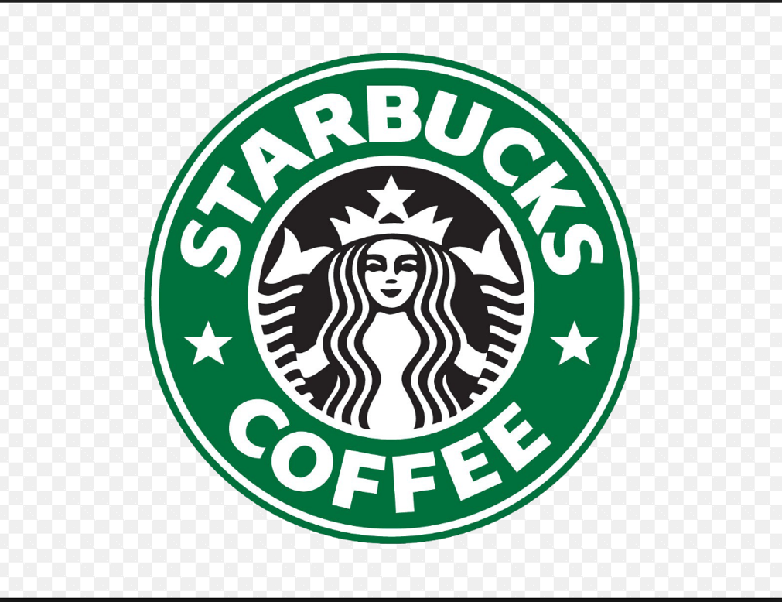
Figure 1.1 Starbucks Type Font Analysis

Figure 2: 2018 Pumpkin Spice Latte
https://news.starbucks.com/facts/fall-arrives-at-starbucks-with-return-of-psl
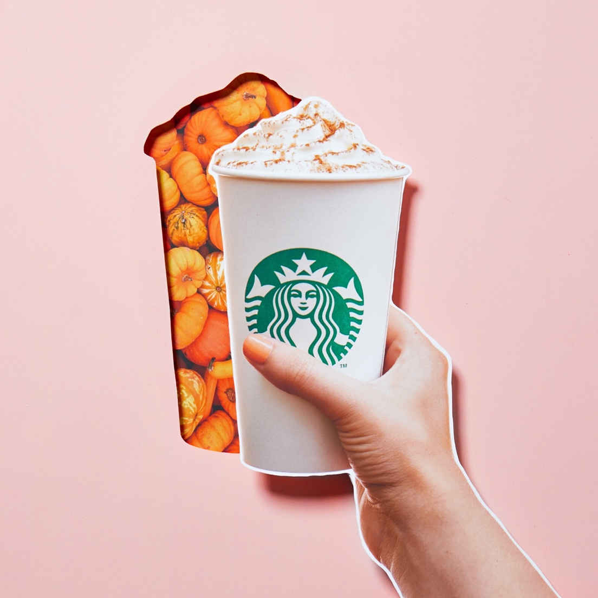

Figure 3. Taco Bell Logo
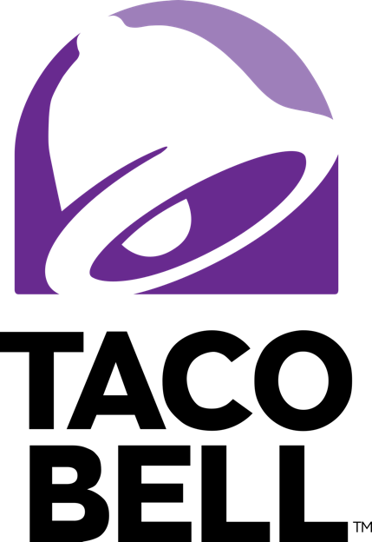
Figure 4: 2018 Crunchwrap Supreme Advertisement
https://www.thedailymeal.com/news/eat/taco-bell-gets-mathematic-new-triple-double-crunchwrap/071516

